2026
Quality Improvement Plan for
Swan Reach Area Kindergarten

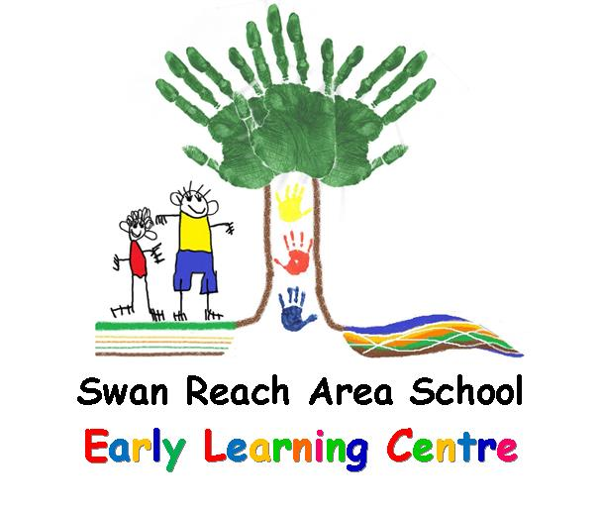

Site number:
6552
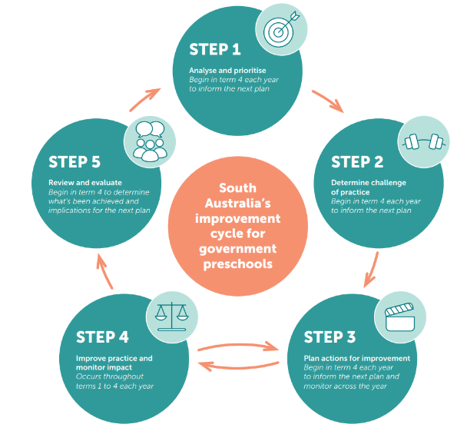

Service name
Swan Reach and Area Kindergarten

Service address
8 Showgrounds Road, Swan Reach, 5354

Service approval number
SE-00011010
Acknowledgment of Country
We acknowledge the Nungaraku People of the Ngarrindjeri Nation as the traditional custodians of the lands and waters where our centre is located and recognise their continuing connection to country. We pay our respects to Elders past and present and extend that respect to all Aboriginal peoples.

Service context
In 2018, Swan Reach and Area Kindergarten amalgamated with Swan Reach Area School to continue the provision of preschool services. The kindergarten operates from the Early Learning Centre, a modern facility that also provides opportunities for programs such as Occasional Care and Playgroup to run in conjunction with the kindergarten program. Due to fluctuating enrolments, the service alternates between being 'in scope' and 'out of scope' for the National Quality Standard (NQS).
Swan Reach and Area Kindergarten is geographically positioned near the centre of three regional districts and major service centres: the Murraylands, the Barossa, and the Riverland. Our preschool receives support from both the Murray Bridge DfE District Office (leadership and educational support) and the Berri DfE District Office (support services).
Enrolments are drawn from a small catchment area that includes the town of Swan Reach, surrounding farmlands, the nearby township of Nildottie, and as far north as Blanchetown, making Swan Reach and Area Kindergarten the closest service for many families.
The Principal leads the preschool team in collaboration with the Early Years teacher, who has curriculum leadership responsibilities, and an Early Childhood SSO2. When enrolments are below the NQS 'in scope' threshold, Swan Reach and Area Kindergarten is able to facilitate a composite preschool/reception class to ensure continuity of service.

Statement of Philosophy
At Swan Reach and Area Kindergarten, we are committed to fostering an inclusive, high-quality learning environment where every child feels a sense of belonging, being, and becoming. We recognise that children are capable, competent, and creative learners who thrive when engaged in stimulating, challenging, and purposeful play-based learning programs that balance child-initiated discovery with intentional teaching.
We value and actively seek out children’s voices, ideas, and interests within our curriculum, embedding respect, trust, and relationships at the heart of our practice. This partnership with children and their families celebrates diversity, promotes wellbeing, and cultivates a love of lifelong learning. We encourage every child to learn at their own pace, follow their passions, and develop dispositions such as gratitude, empathy, mindfulness, and emotional literacy.
We place a strong emphasis on supporting each child to develop self-regulation skills, enabling them to manage their emotions, behaviours, and relationships effectively within a caring and supportive environment.
Our curriculum is guided by:
- The Early Years Learning Framework (Belonging, Being & Becoming) and Respect, Reflect, Relate
- Reflective and ongoing observations of individual children and groups
- Children’s interests, family context, and evolving understandings
- Collaborative input from parents and carers, recognising them as each child’s first educators
We promote a culture of reflection, empowering children to consider their learning and build confidence for the future. Children are supported to make decisions, exercise agency, and develop critical thinking and problem-solving skills in partnership with peers, educators, and adults. Quality interactions, co-construction of knowledge, and positive relationships underpin our approach to supporting children’s holistic development.
Our team of educators is committed to continuous improvement, engaging in daily reflection, documentation of learning, and formative assessment practices. We prioritise professional learning and keep abreast of current research to inform practice, in line with the National Quality Standard and sector expectations.
At Swan Reach and Area Kindergarten, we champion authentic learning experiences within rich natural and built environments, fostering curiosity, awe, and wonder. Sustainable practices are embedded across our kindergarten operations and programs, supporting children to develop a sense of responsibility for their world and community.
Reviewed 5/6/2026

Strengths
With reference to the three exceeding themes:
1. Practice is embedded in service operations
2. Practice is informed by critical reflection
3. Practice is shaped by meaningful engagement with families and/or the community
Quality Area 1: Educational Program and Practice
Theme 1 – Practice is Embedded in Service Operations
Assessment, planning, and reflection cycles are consistently implemented for all children, forming the foundation of everyday practice.
Children’s agency and voices are routinely embedded in daily routines and learning experiences.
Family input and collaboration are a regular, expected part of curriculum planning and review.
Intentional teaching and responsive scaffolding are consistently employed by all educators.
Critical reflection and ongoing improvements are an established part of staff practice.
Diversity and inclusion are authentically embedded across the environment, program, and interactions.
Theme 2 – Practice is Informed by Critical Reflection
Educators consistently engage in regular, collaborative critical reflection on children’s learning, the program, and their teaching practices.
Reflections directly inform changes and improvements to the curriculum, routines, and learning environments.
Diverse perspectives—including those of children, families, and educators—are considered during reflection and planning.
Evidence of reflection is visible in planning documents, meeting notes, and adjustments to practice.
Theme 3 – Practice is Shaped by Meaningful Engagement with Families and/or Community
Families are genuine partners in all aspects of curriculum planning and decision-making, with their feedback regularly sought and acted upon.
Community voices, knowledge, and resources are actively incorporated into the educational program and daily experiences.
Learning goals, experiences, and routines are shaped by the interests, cultures, and contributions of both families and the broader community.
Regular two-way communication builds trust and ensures the program truly reflects family and community priorities.

Strengths
With reference to the three exceeding themes:
1. Practice is embedded in service operations
2. Practice is informed by critical reflection
3. Practice is shaped by meaningful engagement with families and/or the community
Quality Area 2: Children’s Health and Safety
Theme 1 – Practice is Embedded in Service Operations
Comprehensive Health and Hygiene Practices: Health routines, risk management, and responsive support for individual medical needs are consistently and rigorously embedded in daily practice, ensuring all children’s safety and wellbeing.
Empowering, Inclusive Health Support: Children are actively supported to develop self-help, hygiene, and emotional regulation skills, with resources and routines—such as sun safety, mindfulness spaces, and accessible hygiene stations—fully integrated into the environment.
Theme 2 – Practice is Informed by Critical Reflection
Continual Improvement Through Reflection: Health, safety, and wellbeing practices are actively reviewed and enhanced through reflective staff meetings, feedback from families, and ongoing policy review, leading to proactive updates and best-practice implementation.
Collaborative Risk Management: Regular risk assessments and first aid checks are conducted collaboratively—including input from children where appropriate—and documented improvements are actioned promptly to maintain the highest safety standards.
Theme 3 – Practice is Shaped by Meaningful Engagement with Families and/or Community
Strong Family Partnerships: Families are partners in all health planning and risk-minimisation, with regular opportunities for feedback and co-construction of health, safety, and care plans tailored to individual needs.
Community-Connected Health Education: Partnerships with health professionals, emergency services, and local providers enhance the service’s health practices, extend children’s safety learning, and reinforce a culture of healthy living at home and within the community.

Strengths
With reference to the three exceeding themes:
1. Practice is embedded in service operations
2. Practice is informed by critical reflection
3. Practice is shaped by meaningful engagement with families and/or the community
Quality Area 3: Physical Environment
Theme 1 – Practice is Embedded in Service Operations
Child-Centred and Inclusive Design: The environment is purposefully designed to support all learners, with accessible indoor and outdoor spaces, ramps, child-level facilities, and inclusive resources, ensuring every child’s comfort, access, and participation.
Optimal Safety and Upkeep: Daily environment inspections, regular WHS reviews, and quality maintenance practices ensure all equipment and furniture are always safe, clean, and well-maintained, exceeding regulatory standards.
Flexible and Homely Learning Spaces: Multiple quiet and active zones, natural light, comfortable furniture, and soft décor create a warm, inviting atmosphere that supports wellbeing and learning.
Theme 2 – Practice is Informed by Critical Reflection
Continuous Environment Improvement: Educators regularly review and adjust the environment based on observations, staff reflection, and feedback, ensuring areas, resources, and routines meet evolving needs and interests of all children.
Responsive Arrangement and Resources: Children are regularly invited to share their ideas for yard setup and resource choices, with layout and equipment modified to enhance engagement, focus, and collaborative play.
Sustained Risk Management: Risk assessments are reviewed and updated collaboratively, incorporating input from staff, families, and children, ensuring ongoing safety and best practice.
Theme 3 – Practice is Shaped by Meaningful Engagement with Families and/or Community
Strong Family/Community Partnerships: Family and community perspectives inform the physical environment through ongoing dialogue and feedback, and families are welcomed to utilise and participate in learning spaces for play and events.
Community-Connected, Culturally Rich Spaces: The environment reflects local context and cultural practices—including natural and “river living” features—fostering a sense of belonging and shared identity.
Environmentally Responsible Practice: Children actively participate in sustainability initiatives (worm farming, composting, recycling, nature craft), building environmental awareness in partnership with families and community.

Strengths
With reference to the three exceeding themes:
1. Practice is embedded in service operations
2. Practice is informed by critical reflection
3. Practice is shaped by meaningful engagement with families and/or the community
Quality Area 4: Staffing Arrangements
Theme 1 – Practice is Embedded in Service Operations
Consistently High Staffing Ratios and Qualifications: Our deliberate approach to staffing ensures coverage well above required ratios (often 1:3). All staff hold First Aid qualifications and National Child Safety Training, and either hold or are working towards relevant educator qualifications. This underpins robust supervision and high-quality learning.
Strong, Stable and Professional Team: Roles, responsibilities, and rosters are strictly observed (including non-contact time), fostering a committed, enthusiastic, and well-supported teaching team that works seamlessly and enhances children’s learning and wellbeing.
Effective Record Keeping and Compliance: Systems are in place for up-to-date staff records, appointment of responsible and nominated supervisors, and transparency around all educator qualifications and attendance—consistently exceeding compliance requirements.
Theme 2 – Practice is Informed by Critical Reflection
Collaborative Culture of Reflection: Weekly staff meetings prioritise reflective dialogue, affirmation, and inquiry, driving ongoing improvements in practice, relationships, and service delivery. Performance management processes are in place for all staff, grounded in regular feedback.
Professional Learning & Mentoring: Generous investment in professional learning is matched by active mentoring and networking opportunities, including participation in relevant local networks and targeted PL aligning with the PQIP and preschool priorities.
Continuous Policy Calibration: Access to updated professional publications, codes of ethics, and policies (incl. NQS, EYLF, DfE) ensures the team reflects upon, and operates according to, the highest standards and current best practice.
Theme 3 – Practice is Shaped by Meaningful Engagement with Families and/or the Community
Responsive to Family/Community Needs: Staffing is adapted to support children with additional needs, with extra staff recruited as required and families consulted and kept informed of staffing arrangements for their child.
Welcoming, Transparent, and Accessible: Information about staff roles, qualifications, and responsible persons is clearly displayed and regularly updated for families’ reference. Families and community members can engage in student and volunteer placements, fostering strong community connections.
Ethical, Respectful Relationships: A culture of respect, mutual support, and open communication extends to families and colleagues alike; policies for grievance resolution are transparent and actively shared.

Strengths
With reference to the three exceeding themes:
1. Practice is embedded in service operations
2. Practice is informed by critical reflection
3. Practice is shaped by meaningful engagement with families and/or the community
Quality Area 5: Relationships with Children
Theme 1 – Practice is Embedded in Service Operations
Genuine, Respectful Interactions: Positive, consistent, and personalised interactions are the foundation of daily practice. Educators greet every child warmly, listen attentively, and foster a relaxed, happy atmosphere centred on trust, respect, and belonging.
Child Voice and Agency: Children’s ideas, opinions, and choices are actively sought, valued, and embedded in decision-making. Morning meetings and yarning circles provide daily opportunities for children to express themselves and participate in group dialogue.
Dignity and Rights of Every Child: All routines and interactions protect and uphold each child’s dignity and individual rights, including privacy, cultural identity, and comfort.
Theme 2 – Practice is Informed by Critical Reflection
Intentional, Reflective Practice: Staff regularly reflect and collaborate in practitioner inquiry to improve relationships, outcomes, and equity for all children, including those from minority and diverse backgrounds.
Responsive Relationship-Based Planning: Ongoing observation, collaborative learning, and feedback from children and families shape individualised learning plans and strengthen educator responsiveness in daily interactions.
Commitment to Continuous Improvement: Team meetings, program adjustments, and ongoing review of behaviour support, guidance strategies, and wellbeing programs (e.g., Resilience Project) embed ongoing critical reflection.
Theme 3 – Practice is Shaped by Meaningful Engagement with Families and/or the Community
Partnerships with Families: Regular, two-way communication and sharing of information (face-to-face, SeeSaw, phone, communication books) allows educators to learn about each child’s home life, interests, and cultural context, ensuring programming is inclusive and responsive.
Collaborative Problem-Solving and Belonging: Families are welcomed to settle new children, contribute to individual planning, and participate in decision-making, supporting children’s self-regulation and sense of community.
Community and Peer Connections: Children engage in collaborative group work, peer helping, and partner investigations, fostering empathy and strong social skills. Connections to families and the broader school and local community. For example: Floor book stories, assemblies, values programs, and celebrations such as Book Week and Mother’s/Father’s Day, strengthening their sense of belonging and appreciation.

Strengths
With reference to the three exceeding themes:
1. Practice is embedded in service operations
2. Practice is informed by critical reflection
3. Practice is shaped by meaningful engagement with families and/oyr the community
Quality Area 6: Collaborative Partnerships with Families and Communities
Theme 1 – Practice is Embedded in Service Operations
Open and Welcoming Environment: Families are invited to participate at any time, with an open-door policy, regular reporting, and transparent communication embedded in daily practice.
Consistent and Responsive Communication: We use multiple platforms such as newsletters, SeeSaw, phone calls, and communication books to keep families informed and engaged. This approach ensures that families have ongoing access to program updates, child progress information, and service policies.
Seamless Transition Practices: Robust, well-planned transition programs connect families and children from playgroup/occasional care into preschool, and then into school, providing consistency and support throughout.
Theme 2 – Practice is Informed by Critical Reflection
Individualised, Responsive Planning: Learning plans, ILPs, and transition plans are created through genuine collaboration with families and are continuously updated in response to family insights and reflective assessment of each child’s needs.
Inclusive Decision-Making: Families are invited to contribute to the site philosophy and are given opportunities to provide feedback on policies. While contributions to policy review and the philosophy have been sought, feedback has not always been received. This approach aims to ensure the service is responsive to family perspectives and values.
Continuous Service Improvement: Family feedback and community input are regularly sought and considered during reflective team practice to better meet the diverse needs of all children and their families.
Theme 3 – Practice is Shaped by Meaningful Engagement with Families and/or Community
Celebrating Diversity and Community Connections: Cultural backgrounds, traditions, and family values are celebrated and represented in the program; educators invite family and community expertise into the curriculum further deepening community bonds.
Broader Community Engagement: Strong partnerships are forged with local organisations, emergency services, the library, local government, and community groups, maximising children’s sense of belonging, civic engagement, and opportunity for authentic community learning.
Family Support and Advocacy: Current information about services, resources, and tailored family support are consistently available and regularly reviewed in partnership with families and local agencies.

Strengths
With reference to the three exceeding themes:
1. Practice is embedded in service operations
2. Practice is informed by critical reflection
3. Practice is shaped by meaningful engagement with families and/or the community
Quality Area 7: Governance and Leadership
Theme 1 – Practice is Embedded in Service Operations
Robust Governance Structures: The SRAS Governing Council actively supports and oversees all aspects of service operations, including policy endorsement, annual budget approval, compliance monitoring, and continuous improvement, ensuring a high-standard, community-aligned service.
Systems for Quality and Compliance: Comprehensive systems manage all risk, safety, incident reporting and document storage, with ongoing site and financial audits ensuring all legal and regulatory obligations are consistently exceeded.
Clear Roles, Standards, and Ethics: Staff roles and responsibilities are well-defined, and all operate under professional standards and codes of ethics, maintaining a transparent, ethical, and accountable culture.
Theme 2 – Practice is Informed by Critical Reflection
Continuous Quality Improvement: Ongoing self-review using the NQS, responsive PQIP processes, and performance development plans foster a cycle of improvement underpinned by critical reflection and collaborative enquiry.
Reflective Leadership Practices: Regular internal reviews, weekly staff meetings, and whole-site engagement in updating the Statement of Philosophy ensure leadership practice evolves to meet new challenges and community feedback.
Data-Informed Decision-Making: Use of parent surveys, reflective documentation, and assessment cycles strengthen governance priorities and strategic directions.
Theme 3 – Practice is Shaped by Meaningful Engagement with Families and/or Community
Community-Driven Leadership: Families and community, through the Governing Council and open feedback channels, inform policy review, priorities, and service improvement. Council membership actively represents the user base and encourages new family involvement each year.
Transparent and Accessible Communication: Families are regularly informed about governance, policy changes, achievements, and invited to contribute to future directions. Leadership connections extend to local networks and community partners, enriching the service’s capacity.
Responsive, Inclusive Approach: Families’ voices are encouraged and supported to shape the service philosophy, annual reporting, and improvement agenda. This approach fosters a strong sense of shared ownership and community investment.

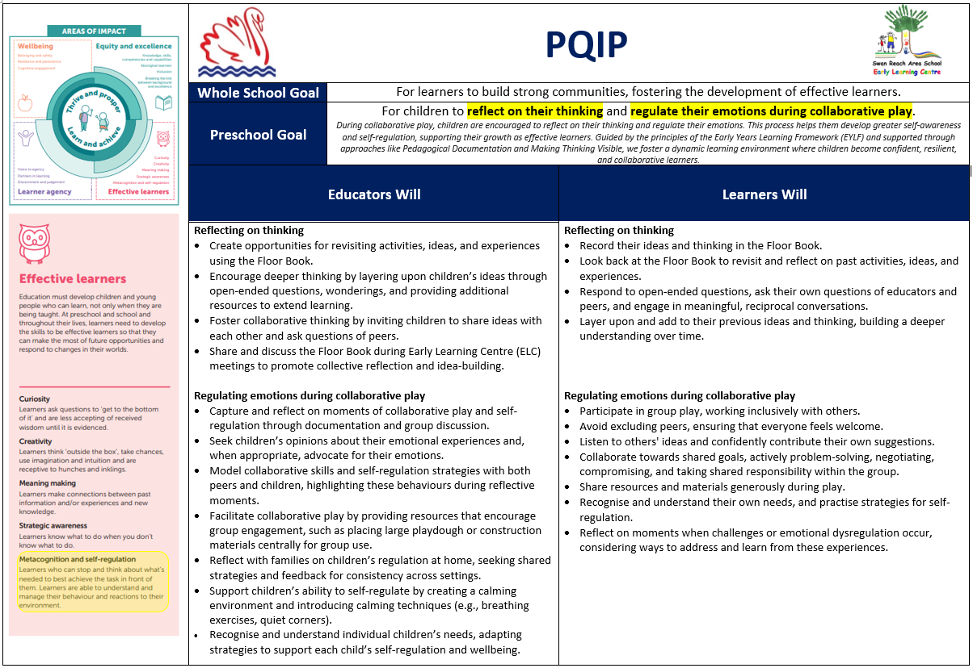
Are we doing what we said we would do? Are we improving children’s learning? How effective have our actions been?
Goal | Children improve their ability to reflect on and regulate their thinking in their own play experiences.  When children engage in metacognitive processes, such as reflecting on their thinking and regulating their learning, the principles of the EYLF and Pedagogical Documentation/Making Thinking Visible can help create a dynamic and engaging environment that encourages self-awareness and self-regulation.
Actions | Educators Will |  |  |  | Children Will |  |  |  | Evidenced by | Next Steps
Reflect on Thinking | - Create opportunities for revisiting activities, ideas, and experiences using the Floor Book. |  |  |  | - Record their ideas and thinking in the Floor Book. |  |  |  | Date:
Reflect on Thinking | - Encourage deeper thinking by layering upon children’s ideas through open-ended questions, wonderings, and providing additional resources to extend learning. |  |  |  | - Look back at the Floor Book to revisit and reflect on past activities, ideas, and experiences. |  |  |  | Date:
Reflect on Thinking | - Foster collaborative thinking by inviting children to share ideas with each other and ask questions of peers. |  |  |  | - Respond to open-ended questions, ask their own questions of educators and peers, and engage in meaningful, reciprocal conversations. |  |  |  | Date:
Reflect on Thinking | - Share and discuss the Floor Book during Early Learning Centre (ELC) meetings to promote collective reflection and idea-building. |  |  |  | - Layer upon and add to their previous ideas and thinking, building a deeper understanding over time. |  |  |  | Date:
Regulate Emotions During Collaborative Play  Engage Families | - Capture and reflect on moments of collaborative play and self-regulation through documentation and group discussion. |  |  |  | - Participate in group play, working inclusively with others. |  |  |  | Date:
Regulate Emotions During Collaborative Play  Engage Families | - Seek children’s opinions about their emotional experiences and, when appropriate, advocate for their emotions. |  |  |  | - Avoid excluding peers, ensuring that everyone feels welcome. |  |  |  | Date:
Regulate Emotions During Collaborative Play  Engage Families | - Model collaborative skills and self-regulation strategies with both peers and children, highlighting these behaviours during reflective moments. |  |  |  | - Listen to others' ideas and confidently contribute their own suggestions. |  |  |  | Date:
 |  |  |  |  |  |  |  |  | Date:
Regulate Emotions During Collaborative Play  Engage Families | - Facilitate collaborative play by providing resources that encourage group engagement, such as placing large playdough or construction materials centrally for group use. |  |  |  | - Collaborate towards shared goals, actively problem-solving, negotiating, compromising, and taking shared responsibility within the group. |  |  |  | Date:
Regulate Emotions During Collaborative Play  Engage Families | - Reflect with families on children’s regulation at home, seeking shared strategies and feedback for consistency across settings. |  |  |  | - Share resources and materials generously during play. |  |  |  | Date:
Regulate Emotions During Collaborative Play  Engage Families | - Support children’s ability to self-regulate by creating a calming environment and introducing calming techniques (e.g., breathing exercises, quiet corners). |  |  |  | - Recognise and understand their own needs, and practise strategies for self-regulation. |  |  |  | Date:
Regulate Emotions During Collaborative Play  Engage Families | Recognise and understand individual children’s needs, adapting strategies to support each child’s self-regulation and wellbeing. |  |  |  | - Reflect on moments when challenges or emotional dysregulation occur, considering ways to address and learn from these experiences. |  |  |  | Date:

Have we achieved our improvement goal? What have we learned and what are our next steps?
What progress have we made? Have we achieved our goal?

Enablers: What factors have been critical for success?

Inhibitors: What factors have impeded progress? How will we work through this?

Recommendations: What are the next steps to take?

National Quality Standard priorities
Priority |  |  |  | Evidenced by | Next Steps
2.2.1  • Educators review excursion risk assessments to ensure that all regulatory requirements are included. |  |  |  | Submitted as part of our re-assessment process. | Waiting on ESB review.
• Educators develop a risk assessment for the outdoor environment such as having the mud kitchen against the fence. |  |  |  | Submitted as part of our re-assessment process. | Waiting on ESB review.
• Educators follow their sun protection policy and ensure that children wear hats while outside. |  |  |  | Submitted as part of our re-assessment process. | Waiting on ESB review.
7.1.2  - Develop comprehensive job descriptions for all educators. |  |  |  | Submitted as part of our re-assessment process. | Waiting on ESB review.
- Review and update excursion risk assessments to ensure all regulatory requirements are included, referring to ACECQA’s risk assessment and management tool (pages 29–33). |  |  |  | Submitted as part of our re-assessment process. | Waiting on ESB review.
- Review and streamline Sun Protection Policies, ensuring a single, coherent policy is in use across the service. |  |  |  | Submitted as part of our re-assessment process. | Waiting on ESB review.
- Strengthen the enrolment process to ensure children with medical conditions do not attend without their medication and relevant plans, with condition clarity confirmed prior to commencement (as per Regulation 90). |  |  |  | Submitted as part of our re-assessment process. | Waiting on ESB review.
- Review the Medical Conditions Policy to ensure all requirements of Regulation 90 are clearly identified, supported by current ACECQA guidance. |  |  |  | Submitted as part of our re-assessment process. | Waiting on ESB review.
7.2.2  - Developing the Educational Leader’s understanding of analysing children’s learning against the EYLF learning outcomes, supported by ACECQA educational leadership resources:  - ACECQA Educational Leadership Resources  - ACECQA Educational Leader Manual |  |  |  | Submitted as part of our re-assessment process. | Waiting on ESB review.
- Continuing to use self-assessment tools to identify improvements and develop continuous improvement goals, using the:  - Self-Assessment Tool for Centre-based Care (Education Standards Board SA) |  |  |  | Submitted as part of our re-assessment process. | Waiting on ESB review.

Have we achieved our NQS priorities? What have we learned and what are our next steps?
What progress have we made? Have we achieved our priorities?

We have made significant progress toward achieving our NQS priorities and have recently submitted evidence for reassessment, with the outcome currently pending ESB review. Through this process, we have learned the importance of embedding structured, collaborative time for staff and maintaining a strong focus on safety in all aspects of our practice. Our next steps include further enhancing our processes for ongoing self-assessment and embedding a culture of continuous improvement, particularly in pedagogical documentation and reflective practice.

Enablers: What factors have been critical for success?

Critical enablers for our success have included:
- Strong leadership and a clear focus on safety
- Scheduled collaborative time for educators
- Supportive connections within our portfolio and with other sites
- Access to educational consultants for guidance on pedagogical documentation
- Commitment from staff to professional growth and reflective practice

Inhibitors: What factors have impeded progress? How will we work through this?

The main inhibitors to progress have been fluctuating enrolments, which impact resourcing and staffing, and the waiting period for ESB reassessment feedback. To address these, we continue to provide above budget stable staffing allocation and remain flexible in our service delivery. We also maintain transparent communication with stakeholders and regularly review our practices to ensure responsiveness and adaptability.

Recommendations: What are the next steps to take?

Our recommended next steps are to:
- Continue embedding structured collaboration and reflective practice
- Act promptly on feedback received from the ESB reassessment process
- Further build educator capacity in pedagogical documentation and self-assessment
- Strengthen family engagement in the ongoing QIP process
- Maintain and grow our collaborative networks across the portfolio for shared learning

Click or tap to enter a date.

Click or tap to enter a date.

Click or tap to enter a date.

